Merkle Trees
A Merkle Tree is simply a binary tree where each node conains a cryptographic hash. The leaf nodes contain hashes of information, the parent nodes contain a hash of the concatinated information of the two leaf nodes. The internal parents nodes contain a concatinated hash of it’s children hashes. This continues until the root node, where the root node contains a hash of it’s two children hashes. Any subsequent change in the leaf nodes or any of the nodes for that matter would completely change the root hash of the merkle tree.
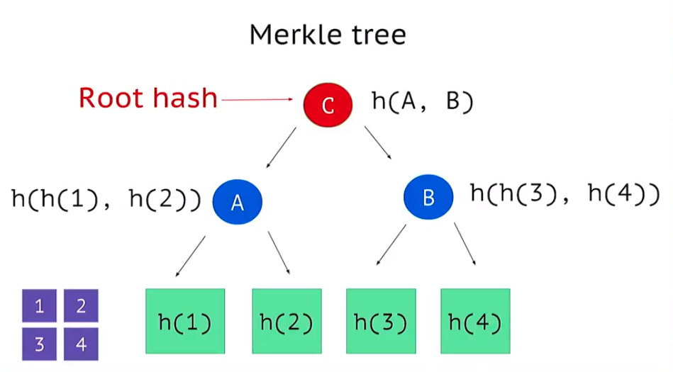
Merkle trees allow for data verification. They allow nodes on a peer to peer network to verify the integrity of a file from an untrustworthy source. All that is needed is the root hash from a trustworthy source, from here a computer can gather information from peers, create a merkle tree and compare if the root hash matches the root hash from the trustworthy source. This process also enables a node on the network to verify the integrity of portions of the file without resulting to gather all the information of that file. All that is needed in this case is the root hash, the data that the node whats to verify, as well as any remaining hashes required to build the merkle root. The merkle root created by the user can then be compared to the merkle root received from the trusted source.
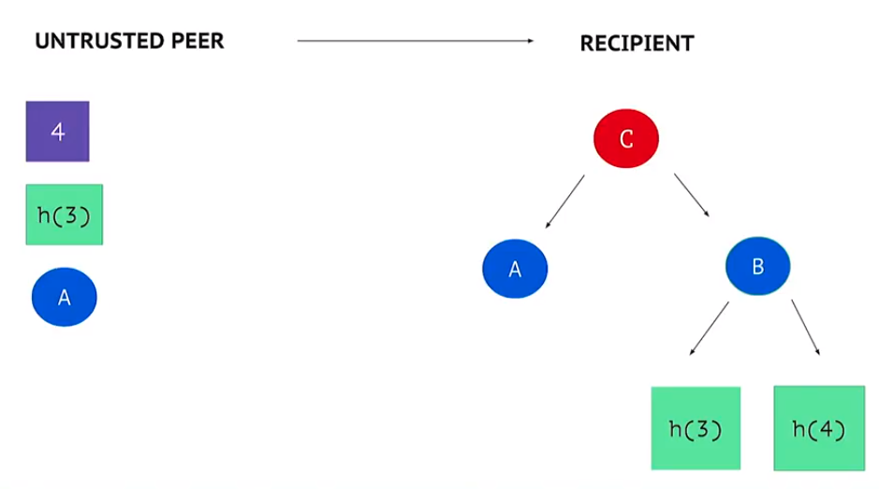
Source of all of the above information: https://www.youtube.com/watch?v=3giNelTfeAk

In bitcoin, this partial verification features of a merkle tree allows a node on the bitcoin network to validate a transaction in a block without downloading all the contents of the block.
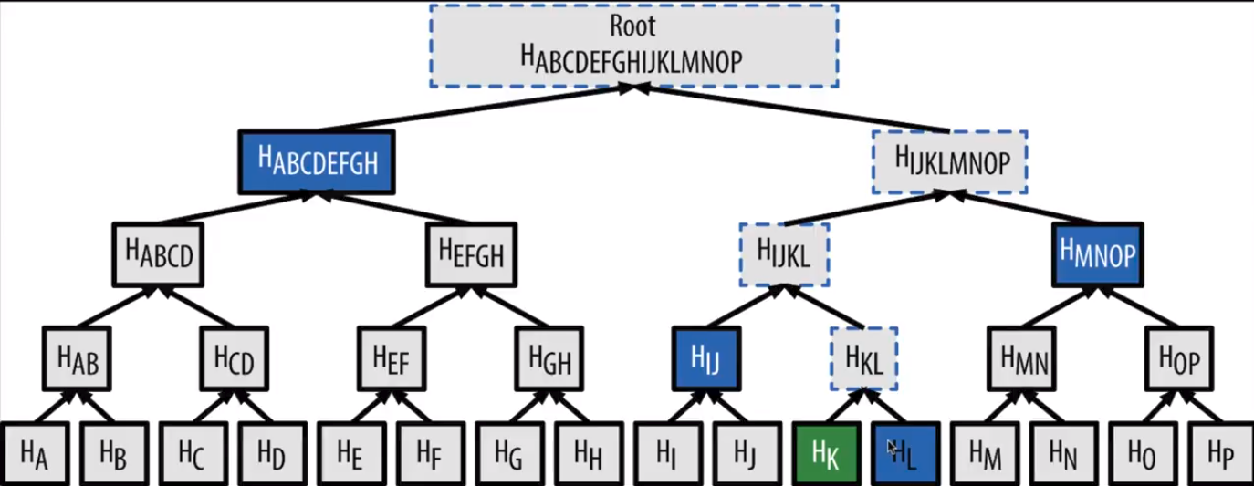
As seen above a light weight computer on the network can verify transaction Hk only with the data from the hashes in blue, using these hashes to then produce the hashes in the dotted blue and compare it to the merkle root of theat block. Source: https://www.youtube.com/watch?v=2kPFSoknlUU

-the raw binary data of the transaction is hashed and added to a leaf node
-if there is an odd number of transactions in a block, the last transaction is hashed with itself to form its parent. If there is an odd number of nodes in a level of the binary tree, then the last node hash is concatinated and hashed with itself to form the hash of its parent.
Source: https://www.youtube.com/watch?v=gUwXCt1qkBU&t=4s

Now there are a couple different methods to implemet the merkle tree data structure. One is via a binary tree ADT, and the other is simply a single array which divides in length every hashing round.
I will be implementing the mrkle tree in terms of a binary tree.

-each transaction is double hashed into the leaf nodes.
-if there are an odd number of transactions, a double hashing of the last transaction is used as the last transaction to form an even pair.
-at each level nodes are concatinated together in pairs of two and double hashed to form its parent. If there is again an odd number of nodes, the last node is duplicated and concatinated to the second last node before being double hashed and forming the parent node.
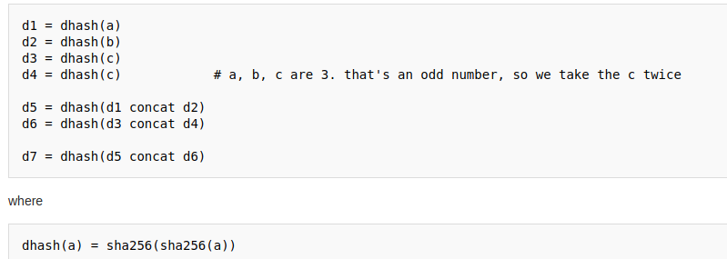

Source: https://en.bitcoin.it/wiki/Protocol_documentation#Merkle_Trees

import hashlib
# Hash pairs of items recursively until a single value is obtained
def merkle(hashList):
if len(hashList) == 1:
return hashList[0]
newHashList = []
# Process pairs. For odd length, the last is skipped
for i in range(0, len(hashList)-1, 2):
newHashList.append(hash2(hashList[i], hashList[i+1]))
if len(hashList) % 2 == 1: # odd, hash last item twice
newHashList.append(hash2(hashList[-1], hashList[-1]))
return merkle(newHashList)
def hash2(a, b):
# Reverse inputs before and after hashing
# due to big-endian / little-endian nonsense
a1 = a.decode('hex')[::-1]
b1 = b.decode('hex')[::-1]
h = hashlib.sha256(hashlib.sha256(a1+b1).digest()).digest()
return h[::-1].encode('hex')
# https://blockexplorer.com/block/0000000000000000e067a478024addfecdc93628978aa52d91fabd4292982a50
txHashes = [
"00baf6626abc2df808da36a518c69f09b0d2ed0a79421ccfde4f559d2e42128b",
"91c5e9f288437262f218c60f986e8bc10fb35ab3b9f6de477ff0eb554da89dea",
"46685c94b82b84fa05b6a0f36de6ff46475520113d5cb8c6fb060e043a0dbc5c",
"ba7ed2544c78ad793ef5bb0ebe0b1c62e8eb9404691165ffcb08662d1733d7a8",
"b8dc1b7b7ed847c3595e7b02dbd7372aa221756b718c5f2943c75654faf48589",
"25074ef168a061fcc8663b4554a31b617683abc33b72d2e2834f9329c93f8214",
"0fb8e311bffffadc6dc4928d7da9e142951d3ba726c8bde2cf1489b62fb9ebc5",
"c67c79204e681c8bb453195db8ca7d61d4692f0098514ca198ccfd1b59dbcee3",
"bd27570a6cbd8ad026bfdb8909fdae9321788f0643dea195f39cd84a60a1901b",
"41a06e53ffc5108358ddcec05b029763d714ae9f33c5403735e8dee78027fe74",
"cc2696b44cb07612c316f24c07092956f7d8b6e0d48f758572e0d611d1da6fb9",
"8fc508772c60ace7bfeb3f5f3a507659285ea6f351ac0474a0a9710c7673d4fd",
"62fed508c095446d971580099f976428fc069f32e966a40a991953b798b28684",
"928eadbc39196b95147416eedf6f635dcff818916da65419904df8fde977d5db",
"b137e685df7c1dffe031fb966a0923bb5d0e56f381e730bc01c6d5244cfe47c1",
"b92207cee1f9e0bfbd797b05a738fab9de9c799b74f54f6b922f20bd5ec23dd6",
"29d6f37ada0481375b6903c6480a81f8deaf2dcdba03411ed9e8d3e5684d02dd",
"48158deb116e4fd0429fbbbae61e8e68cb6d0e0c4465ff9a6a990037f88c489c",
"be64ea86960864cc0a0236bbb11f232faf5b19ae6e2c85518628f5fae37ec1ca",
"081363552e9fff7461f1fc6663e1abd0fb2dd1c54931e177479a18c4c26260e8",
"eb87c25dd2b2537b1ff3dbabc420e422e2a801f1bededa6fa49ef7980feaef70",
"339e16fcc11deb61ccb548239270af43f5ad34c321416bada4b8d66467b1c697",
"4ad6417a3a04179482ed2e4b7251c396e38841c6fba8d2ce9543337ab7c93c02",
"c28a45cded020bf424b400ffc9cb6f2f85601934f18c34a4f78283247192056a",
"882037cc9e3ee6ddc2d3eba86b7ca163533b5d3cbb16eaa38696bb0a2ea1137e",
"179bb936305b46bb0a9df330f8701984c725a60e063ad5892fa97461570b5c04",
"9517c585d1578cb327b7988f38e1a15c663955ea288a2292b40d27f232fbb980",
"2c7e07d0cf42e5520bcbfe2f5ef63761a9ab9d7ccb00ea346195eae030f3b86f",
"534f631fc42ae2d309670e01c7a0890e4bfb65bae798522ca14df09c81b09734",
"104643385619adb848593eb668a8066d1f32650edf35e74b0fc3306cb6719448",
"87ac990808239c768182a752f4f71cd98558397072883c7e137efb49d22b9231",
"9b3e2f1c47d59a444e9b6dc725f0ac6baf160d22f3a9d399434e5e65b14eccb0",
"fbe123066ae5add633a542f151663db4eb5a7053e388faadb40240671ae1b09b",
"1dd07e92e20b3cb9208af040031f7cfc4efd46cc31ec27be20a1047965a42849",
"2709bb9ed27353c1fd76b9240cab7576a44de68945e256ad44b2cb8d849a8060",
"d0174db2c712573432a7869c1508f371f3a1058aeedddc1b53a7e04d7c56c725",
"b4a16f724cddb8f77ddf3d2146a12c4be13d503885eaba3518a03da005009f62",
"2aa706d75decbe57745e01d46f9f5d30a08dedaf3288cee14cc4948e3684e1d4",
"ee49c5f6a5129ccaf2abebbc1d6d07a402a600af6221476b89aafaa683ca95b7",
"bea1011c77874845e9b4c876ed2ceebd530d428dd4a564ad003d9211d40bb091",
"f1e88ffc2b1de2aa4827002f06943ce5468735f7433f960bf01e75885b9f832b",
"19247d017e002fb9143d1a89eb921222a94f8a3d0faaf2e05b0f594989edc4c4",
"13f714ff62ee7d26b6d69ca980c141ebc54e9f71d2697083fe6c5efc1b02bd0f",
"0c78cbb8246572f015fbdc53dc9798fa54d1119ec77c1f07ac310bcbcc40dbf8",
"4bcde0ef92a6d24a2be7be50ac5e5299d776df2e6229ba5d475c2491da94f255",
"0cfd7d1058502730cf0b2ffa880c78ef534651e06832b5d87c0d7eb84eac5b0c",
"3a168f794d6e0c614429ad874317cc4cd67a8177214880ff6ea1704d29228c2f",
"f9a555d817334397b402518d6fd959dc73d981ee7f5fe67969b63974ebbef127",
"24b52691f66eaed4ce391a473902e309018257c98b9f02aaa33b399c9e6f3168",
"a37b5e623dc26a180d9e2c9510d06885b014e86e533adb63ec40511e10b55046",
"9dbaeb485e51d9e25a5621dc46e0bc0aaf51fb26be5acc4e370b96f62c469b80",
"a6431d3d39f6c38c5df48405090752cab03bfdf5c77cf881b18a946807fba74a",
"faa77e309f125373acf19855dd496fffe2f74962e545420844557a3adc7ebc11",
"3523f52543ecfea2f78486dc91550fad0e6467d46d9d9c82ca63b2e0230bfa71",
"a0583e358e42d77d18d1fd0533ff0a65615fc3b3112061ef92f168a00bf640c1",
"42ae900888d5e5dde59c8e3d06e13db9e84ef05d27726d4b67fd00c50cd9406a",
"154940777d3ff78f592ef02790131a59263c36b4958bbc836f9a767ea1a9f178",
"6a0337de6ac75eecf748306e8ebc5bfe5c811a1481ae50f6956a9e7f26a679f5",
"c99530c2148e09688d0b88795625943371183bf1f5d56c7446c6ed51ea133589",
"626421dbe8ad6a0fd0d622d5dd3308a1cdc00b98575a41a91fe01a439e6f40bd",
"b2f3a559f605a158cc395126c3cf394a7e92a53b7514c75157e1dc43a6c7f93e",
"dffe06d1bea81f2a01c76786404bb867258f9e68013bf25454097ce935090738",
"0860159ec7a2a51ce107c182a988c40b4bc2057a734354a1219b6c65e72640ed",
"a405ff1bb51846b1867acc0b0da17f6f9616e592a0a7ff5ef3297c1ecfd60911",
"a7d451924263284765f6343bca8a21b79b89ebfe611c7355dd88e0ec1c29e232",
"41c758d08a4d3fe4d90645711589b832a2cd54dd25bd5b66e463e5d389a53aff",
"a05c1a93a521fa5dbc1790cfbb808893453a428a65f2c6b2d51249fbb12db309",
"90997920aa9786e10f513cfdd14e294feee6739cee1ab61b3fb1e3f42e7a915d",
"99fcb9cb62c20a3135484a70bd3f73983f8f3b7b26266dad34f3993958a7642c",
"e05f9a668b37e5f78bd3b9d047f29f92b33a87f11dd48390410006f858188b7b",
"56dbc65895f7992da4a6985e7edba4d1c00879f1b28442c644c8a07658ceab27",
"5e9004fe262b829563d0804656ba68b1de1690401f08a1915273230d8c902fc0",
"1ea9ed3717523c5e304b7a7ac8058a87fb4f3fed8c6004769f226c9bb67e79c5",
"f0f1a4c009b3f1b2729e89898e2f5c0fcdc312edea5df884a9c897cb90e4c566",
"b5bb4ddf04863e6a60f33cb96c20dac8175d3bae55f335781503143c97a50e43",
"f14cc97a20c6f627b4b78301352ae35463bc359362589cd178a06c0fa90850b7",
"628801c8f614015c0fa0ccb2768cccc3e7b9d41ceed06071ce2534d31f7236d6",
"3be1013c8f8da150e2195408093153b55b08b037fd92db8bb5e803f4c2538aae",
"c9e1f8777685f54ba65c4e02915fd649ee1edcbf9c77ddf584b943d27efb86c3",
"4274e92ed3bd02eb101baa5fb8ff7b96236830762d08273749fbb5166db8ab0b",
"aa84c955bea04c7cee8f5bbbec97d25930fcaca363eed1b8cad37b931556d3e3",
"d6a29c948677fb1f71aaf16debc3d071a4dd349458eb9e056dce3a000ff853da",
"ba84bdb3d78367ca365016ac4bff9269576eb010f874c2967af73e0de5638de0",
"1546c79951e3b541bc64d1957b565b7a2850fc87192c7b374aee6cfc69b9805e",
"f119227d492ebe27fe9aae321980802454dfa64b2691efbe796c5075d5b07f62",
"b8cf13d64818b32f96bbb585998b1bc9505f6a94055488e5a71fee9479c6f2a9",
"1aaf459705b6afef2d7b83e3f181f1af55be0813daf55edce104cc59abc28ed7",
"61ac185c8f520b5e3134953dc52ff292a40e1e96b088dab259558a9d240ec02f",
"2da96e3154d7ec2329f787b73cb8a436b92d64cf3cc28e920d073279ea73b5f8",
"1c4d72ce733b971b9ec4e24f37d733355f6f2ea635cc67ffb3e22748484df446",
"2a6f89769f3272ac8c7a36a42a57627eca6b260ab2c76d8046a27d44d4034893",
"f8d11df51a2cc113698ebf39a958fe81179d7d973d2044322771c0fe63f4d7c9",
"f2287f17a4fa232dca5715c24a92f7112402a8101b9a7b276fb8c8f617376b90",
"bb5ee510a4fda29cae30c97e7eee80569d3ec3598465f2d7e0674c395e0256e9",
"647ab8c84365620d60f2523505d14bd230b5e650c96dee48be47770063ee7461",
"34b06018fcc33ba6ebb01198d785b0629fbdc5d1948f688059158f053093f08b",
"ff58b258dab0d7f36a2908e6c75229ce308d34806289c912a1a5f39a5aa71f9f",
"232fc124803668a9f23b1c3bcb1134274303f5c0e1b0e27c9b6c7db59f0e2a4d",
"27a0797cc5b042ba4c11e72a9555d13a67f00161550b32ede0511718b22dbc2c",
]
print merkle(txHashes)
Merkle root is 871714dcbae6c8193a2bb9b2a69fe1c0440399f38d94b3a0f1b447275a29978a
Source: http://www.righto.com/2014/02/bitcoin-mining-hard-way-algorithms.html

From my analysis of the python code above:
-the transaction id’s (or hashes), before they are used to create their parent node, they are both first reversed (little endian) then they are concatinated and then they are double hashed. After they are double hashed they are reversed again. This is how the tree is formed, each node has a (big endian) verson of the hash, this is reversed before concatination and double hashing and reversed afterwards. If the idea is to just produce the root hash then all that is necessary is just reverse the transaction hashes once before concatination and double hashing and then once the merkle root is found reverse this, all you need is 2 byte reversals rather than 2*log2(N)*(#of nodes).

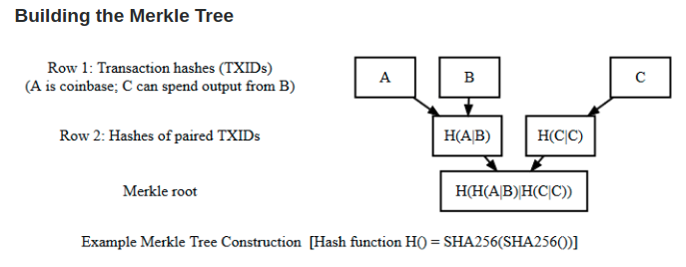
-If the Coinbase transaction is the only transaction in the block, then the coinbase transaction’s hash is the merkle root and a binary tree is not created.
Source: https://bitcoin.stackexchange.com/questions/37223/pairing-pattern-of-txids-in-merkle-tree

Important Technical Source: http://www.righto.com/2014/02/bitcoins-hard-way-using-raw-bitcoin.html

I will now implement a C version of a Binary Merkle Tree ADT along with functions to get the merkle root etc.

